Smart Attendance System: using Face Detection and RFID Integration

Dr. Venugeetha Y¹, Abhishek H², Adeeb Ahemd³, Balaji M⁴, Dhanu Kumar TN⁵ Computer Science and Engineering, Don Bosco Institute of Technology, Bangalore- 560074
vgydbit@gmail.com¹, abhih601@gmail.com², zamadeebahmed@gmail.com³, princebalu911@gmail.com⁴, dhanukumartn2003@gmail.com⁵

Abstract— In order to improve accuracy, efficiency, and security, automated attendance management is essential in contemporary institutions. Manual roll calls and RFID-only identification are examples of traditional attendance techniques that are prone to mistakes, time consumption, and proxy attendance. The Smart Attendance System presented in this study offers a dual-layer verification method by combining RFID authentication and face recognition. RFID technology provides an additional degree of protection by guaranteeing the presence of the registered user, while the system uses Python, OpenCV, and the face-recognition library to identify people with high accuracy. Because the attendance records are kept in a database, they can be easily retrieved and monitored in real time. Compared to stand-alone biometric or RFID systems, the suggested method increases security, decreases authentication time, and improves identification accuracy. An average recognition accuracy of 95%, a 70% decrease in attendance tracking time, and the removal of proxy attendance cases were all proven in an experimental assessment on a dataset of 100 people. Because of its scalability, the system may be included into corporate offices, educational institutions, and smart workplaces. Future improvements will include IoT connectivity for real-time remote access and monitoring, as well as face recognition based on deep learning for increased robustness.

Keywords- Face Recognition, RFID authentication, attendance management, automation, machine learning, database, dual-layer authentication.
- INTRODUCTION

In a variety of settings, such as workplaces, business organizations, and educational institutions, tracking attendance is an essential administrative task. Human error, time inefficiency, and the potential for proxy attendance are just a few of the major drawbacks of traditional attendance systems like manual roll calls, paper-based records, and RFID-only identification. The creation of smart attendance systems that incorporate several authentication technologies is a result of the growing need for automation, accuracy, and security.
Because facial recognition is simple to use and non-intrusive, it has become a dependable biometric method for identification verification. By verifying that the face identification and the RFID credentials match before recording attendance, the technology improves security when paired with RFID authentication. By combining these two technologies, dual-layer authentication is provided, greatly lowering attendance fraud and illegal access.
The suggested Smart Attendance System effectively detects and validates faces while concurrently validating RFID credentials by utilizing Python, OpenCV, and MySQL. This system is made to be real-time, scalable, and flexible enough to work in a variety of settings, including security facilities, corporate offices, and educational institutions. The system design, methodology, implementation specifics, experimental findings, and conclusions are described in the parts that follow.

RELATED WORKS

Several studies have explored biometric and RFID-based attendance systems.
Keerthana et al. [1] proposed an RFID-based attendance system combined with facial recognition for enhanced security.
Zhao et al. [2] introduced an IoT-enabled classroom attendance system utilizing RFID and face detection. These studies highlight the advantages of automation in attendance management but also emphasize challenges such as lighting conditions and processing delays.
Uppanapalli and Krithiga [3] developed a facial emotion detection model using convolutional neural networks (CNNs) and uniform local binary patterns to analyze student behavior during attendance marking.
Seo et al. [4] improved authentication schemes by integrating RFID tags with facial recognition, ensuring better security in smart environments.
Mingtao et al. [5] discussed smart classroom attendance systems leveraging the Internet of Things (IoT) and real-time data processing to enhance monitoring.
Dae-Hee et al. [6] examined an improved dual-layer authentication system combining biometrics with RFID authentication to prevent identity spoofing.
These studies collectively demonstrate the benefits of integrating biometric and RFID-based solutions in attendance management systems, highlighting challenges such as computational efficiency, security vulnerabilities, and scalability issues.

- PROPOSED SYSTEM

By combining facial recognition and RFID verification, the suggested Smart Attendance System provides a more effective and safe solution to the drawbacks of conventional attendance management techniques. This dual-layer authentication reduces the possibility of proxy attendance and unlawful access by ensuring that only registered persons may indicate their presence, in contrast to traditional biometric or RFID-based systems. The suggested system has several important improvements, including:
  - Automated authentication: Gets rid of paper-based tracking and laborious roll calls.
  - Dual-layer Security: Prevents identity fraud by combining real-time face recognition with RFID card scanning.
  - Real-time Processing: Instantaneously updates records and verifies attendance using Python, OpenCV, and MySQL.
  - User-friendly Interface: Offers an easy-to-use dashboard for tracking staff or student attendance.

DESIGN OF THE SYSTEM

    - Overview of the System:
- Face Recognition: Accurately identifies people using OpenCV and face-recognition frameworks.
- RFID Authentication: Verifies attendance using RFID readers and Arduino.
- Database administration: RFID credentials, face information, and attendance records are stored in MySQL.
- User Interface: Offers an easy-to-use dashboard for tracking attendance.

    - Architecture of the System:
- Input Layer: An RFID scanner scans the card while a camera takes live facial photos.
- Processing Layer: RFID credentials are checked against the database, and face recognition algorithms compare facial data.
- Storage Layer: MySQL securely stores RFID information, attendance records, and face data.
- Output Layer: An Excel sheet records the attendance status and is shown on the interface.
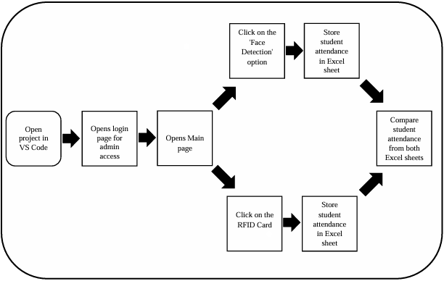
Fig 1: Sequential representation of the working project

    - Specifics of Implementation:
- OpenCV: Recognition and detection of faces.
- Face recognition: Verification and feature extraction.
- MySQL Connector: Interaction with databases.
- It validates RFID authentication using an Arduino and an MFRC522 RFID module.

    - Face Recognition using LBPH
For face recognition, the system makes use of the Local Binary Pattern Histogram (LBPH) technique. LBPH functions by:
- creating 3x3 pixel matrices from grayscale photos.
- establishing a binary pattern by applying a threshold.
- producing a distinct feature vector for every face by generating a histogram of patterns.
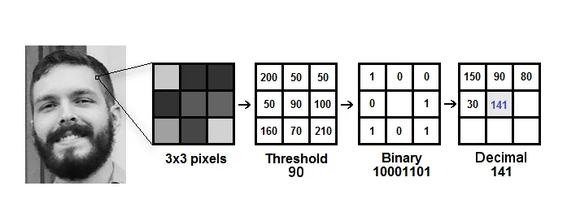
- identifying people by comparing recently taken photos with feature vectors that have been preserved.
Fig 2: Working of the LPAH Algorithm
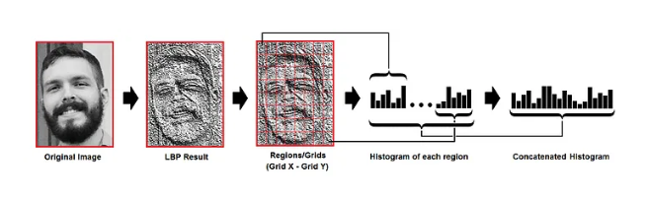
Fig 3: Extracting the histogram of each region

    - RFID Authentication Process
- Every user is given a distinct RFID tag that is connected to their MySQL database profile.
- Before permitting attendance marking, the system verifies the RFID data after scanning it.
- Higher security is ensured and unwanted access is avoided with this twofold verification.
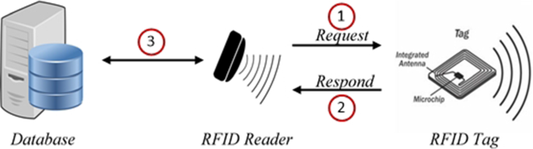
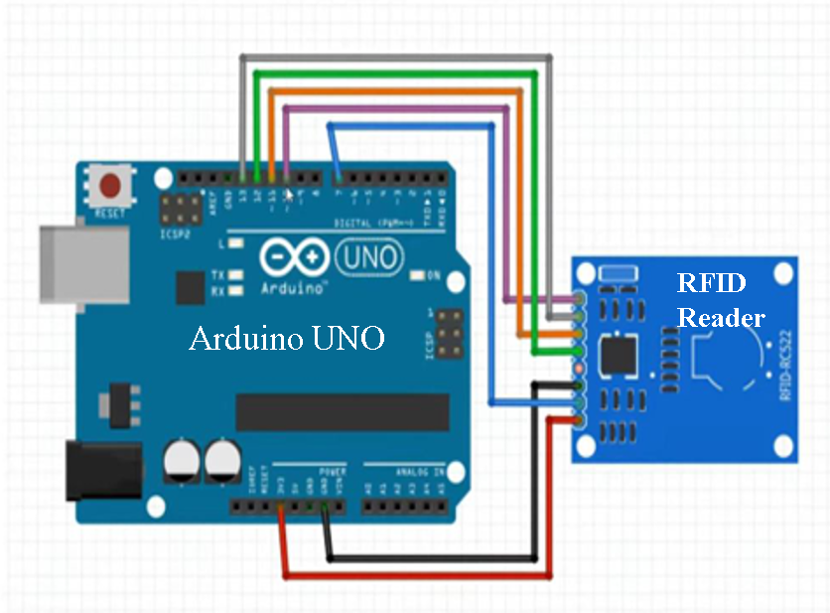
Fig 3: RFID Work flow

Fig 4: RFID-based system flow

- EXPERIMENTAL REULTS

One hundred users served as the dataset for the system's real-world testing. Among the important conclusions are:
- 95% identification accuracy under ideal lighting conditions.
- Speed: When compared to manual approaches, the time spent recording attendance was reduced by 70%.
- Dual-layer authentication keeps proxy attendance at bay.
- Scalability: Real-time processing and many users may be handled well by the system.
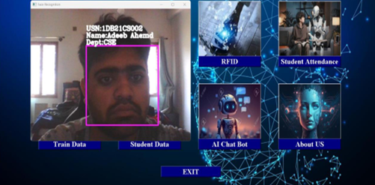
Fig 5: The Student's Face Was Successfully Detected.


Fig 6: The Student's RFID card was successfully scanned

- CONCLUSION

The suggested Smart Attendance System offers a sophisticated, dependable, and secure attendance management solution by skillfully combining facial recognition and RFID verification. Compared to conventional techniques, this dual-layer authentication reduces proxy attendance, increases security, and boosts efficiency.
The technology guarantees smooth user interaction, drastically cuts down on attendance tracking time, and exhibits a high identification accuracy of 95%. Because of its versatility, it may be used in corporate offices, educational institutions, and other safe work environments.

- FUTURE WORK

- Using Deep Learning Models: To increase the precision of facial recognition in different occlusion and lighting scenarios.
- Cloud-based attendance storage, monitoring, and real-time remote access are made possible via IoT and cloud integration.
- Mobile Application Development: Enabling the use of cellphones with RFID identification and facial recognition to indicate attendance.
- Enhancements in Scalability: Improving database performance to accommodate big businesses.
The system will become a complete solution for contemporary attendance management by incorporating these developments, which will also improve security, effectiveness, and usability.

- REFERENCES

[1] Keerthana Sanath, Meenakshi K, Muktha Rajan, Varshini Balamurugan, and M.E. Harikumar, “RFID and Face Recognition based Smart Attendance System”, Fifth International Conference on Computing Methodologies and Communication (ICCMC 2021), IEEE Xplore Part Number: CFP21K25-ART.
[2] Bing-Zhong Jing, Patrick P. K. Chan, Wing W. Y. Ng, and Daniel S. Yeung, “Anti-Spoofing System for RFID Access Control Combining with Face Recognition”, Ninth International Conference on Machine Learning and Cybernetics, Qingdao, 11-14 July 2010 @ IEEE.
[3] Uppanapalli Lakshmi Sowjanya and R. Krithiga, “Facial Emotion Detection Model Using CNNs and Uniform Local Binary Pattern (uLBP) to analyze student behavior,” IEEE Access, Vol. 12, 2024.
[4] Dae-Hee Seo, Jang-Mi Baek and Mi-Yeon Yoon, “Improved Authentication Scheme using Facial Recognition scheme based on RFID Tag”, 2010 International Conference on Multimedia Information Networking and Security, Nanjing, China, 17 December 2010 @IEEE.
[5] Mingtao Zhao , Gang Zhao , and Meihong Qu, “College Smart Classroom Attendance Management System Based on Internet of Things”, Hindawi, Computational Intelligence and Neuroscience, Volume 2022, Article ID 4953721.
[6] Narayana Darapaneni, Aruna Kumari Evoori and Dhivakar Babu, “Automatic Face Detection and Recognition for Attendance Maintenance”, 15th (IEEE) International Conference on Industrial and Information Systems (ICIIS), 2020.

